EX9 – HAMMING CODE
- S. Vishakan CSE – C 18 5001 196

Server Program:

#include "Hamming.h"
#include <string.h>
#include <sys/types.h>
#include <sys/socket.h>
#include <netinet/in.h>

#define PORT 7229

int main(void){
int sockfd, newfd, len, flag, i, *hammed_data, *error_data;
int data_bits, total_bits, parity_bits;
struct sockaddr_in server_address, client_address;
char buffer[1024];

printf("\n\t\tHamming Code\n");
printf("\nEnter the no. of data bits\t:\t");
scanf("%d", &data_bits);

printf("\nEnter the data\t\t\t:\t");

int data[data_bits];

for(i = 0; i < data_bits; i++){
scanf("%1d", &data[i]);
}

parity_bits = findParityBits(data_bits);
printf("\nThe no. of parity bits\t\t:\t%d", parity_bits);
total_bits = parity_bits + data_bits;

hammed_data = putParityBits(data, data_bits);
printf("\nHamming Encoded Data\t\t:\t");
printMessage(hammed_data, total_bits);

printf("\nSimulating error by flipping a random bit.");
error_data = flipABit(hammed_data, total_bits);

printf("\nData with error\t\t\t:\t");
printMessage(error_data, total_bits);

for(i = 0; i < total_bits; i++){
buffer[i] = error_data[i] + '0';
}

buffer[i] = '\0';

sockfd = socket(AF_INET, SOCK_STREAM, 0);

if(sockfd < 0){ //Error has occurred.
perror("Socket cannot be created.\n");
exit(1);
}

bzero(&server_address, sizeof(server_address));

server_address.sin_family = AF_INET;
server_address.sin_addr.s_addr = INADDR_ANY;
server_address.sin_port = htons(PORT);

if(bind(sockfd, (struct sockaddr*)&server_address, sizeof(server_address)) < 0){
perror("Bind error occurred.\n");
exit(1);
}

printf("\n\nWaiting for client at port %d...\n", PORT);
listen(sockfd, 2);
len = sizeof(client_address);

newfd = accept(sockfd, (struct sockaddr*)&client_address, &len);

flag = send(newfd, buffer, sizeof(buffer), 0);
printf("\nSent the data\t\t:\t\t%s\n", buffer);

close(sockfd);
close(newfd);

return 0;
}

Output:

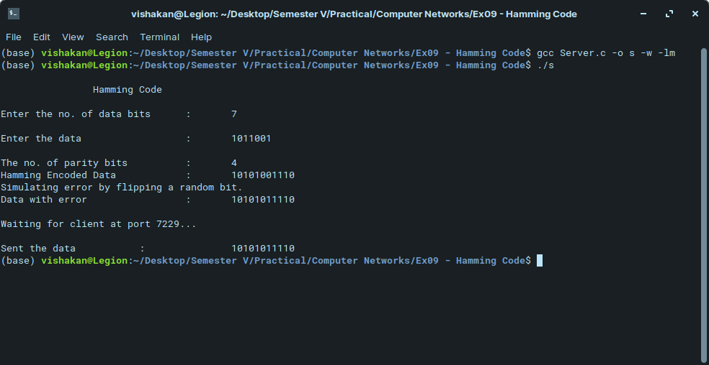
Client Program:

#include "Hamming.h"
#include <string.h>
#include <sys/types.h>
#include <sys/socket.h>
#include <netinet/in.h>

#define PORT 7229

int main(void){
int sockfd, flag, len, i;
int *data, data_bits, parity_bits, total_bits;
struct sockaddr_in server_address, client_address;
char buffer[1024];

sockfd = socket(AF_INET, SOCK_STREAM, 0);

if(sockfd < 0){
perror("Socket cannot be created.\n");
exit(1);
}

bzero(&server_address, sizeof(server_address));

server_address.sin_family = AF_INET;
server_address.sin_addr.s_addr = inet_addr("127.0.0.1");
server_address.sin_port = htons(7229);

connect(sockfd, (struct sockaddr*)&server_address, sizeof(server_address));

flag = recv(sockfd, buffer, sizeof(buffer), 0);

printf("Server sent the data\t:\t%s\n", buffer);

total_bits = strlen(buffer);

int hammed_data[total_bits];

for(i = 0; i < total_bits; i++){
hammed_data[i] = buffer[i] - '0';
}

parity_bits = findParityBits(total_bits);

printf("\nChecking for errors in data.");
data = detectError(hammed_data, total_bits, parity_bits);

printf("\nRetrieving the original message.");
data = getMessage(data, total_bits, parity_bits);

printf("\nOriginal message\t:\t");
printMessage(data, total_bits – parity_bits);
printf("\n");

close(sockfd);

return 0;
}

Output:

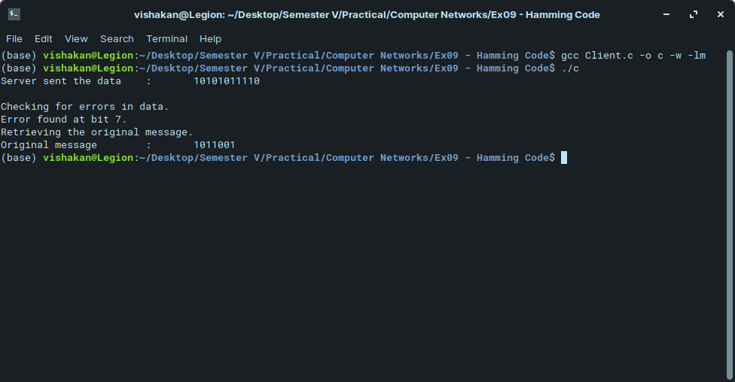

Header File “Hamming.h”:

#include <stdio.h>
#include <stdlib.h>
#include <math.h>

int findParityBits(int msg_bits);
int *putParityBits(int *data, int data_bits);
int *flipABit(int *data, int bits);
int *detectError(int *array, int bits, int parity_bits);
int *getMessage(int *hammed_data, int bits, int parity_bits);
void printMessage(int *data, int bits);
long convertBinToDec(long bin_value);
int *reverseArray(int *array, int len);

int findParityBits(int msg_bits){
//Calculates the number of parity bits required
int i = 0;

//No. of redundant bits are always power of 2 that is greater than the whole message size
while(pow(2, i) < msg_bits + i + 1){
i += 1;
}

return i;
}

int *putParityBits(int *data, int data_bits){
//Places the required parity bits on a given array of data
//Even parity is assumed here
int i = 0, j = 0, k = 0, parity_bits = 0, total_bits = 0;
int *hammed_data, bit_value = 0, parity_pos = 0;

parity_bits = findParityBits(data_bits);
total_bits = parity_bits + data_bits;
hammed_data = (int *)malloc(sizeof(int) * total_bits);

data = reverseArray(data, data_bits);

for(i = 0; i < total_bits; i++){
//Insert empty parity bits at the correct position
if(i == ((1 << j) - 1)){ // 1 << i == 2^i in binary
hammed_data[i] = 0;
j++;
}

else{
hammed_data[i] = data[k];
k++;
}
}

for(i = 0; i < total_bits; i++){
//Calculate the parity values for each parity bit

for(j = 0; j < parity_bits; j++){
bit_value = ((i + 1) & (1 << j));

if(bit_value){
//Implies the index value is not a power of 2, thus a data bit is at 'i'
parity_pos = (1 << j) - 1;
hammed_data[parity_pos] = hammed_data[parity_pos] ^ hammed_data[i];
}
}
}

return reverseArray(hammed_data, total_bits);
}

int *flipABit(int *data, int bits){
//Flips a random bit in the data to simulate error
int pos;

pos = rand() % bits;
data[pos] = (data[pos] + 1) % 2;

return data;
}

int *detectError(int *data, int bits, int parity_bits){
//Detects the error (and corrects, if possible)
int i = 0, j = 0, parity_pos, bit_value;
int new_parity = 0, error_pos = 0, *new_data;

data = reverseArray(data, bits);

for(j = parity_bits - 1; j >= 0; j--){
//Calculate the parity values again for each parity bit
//and compare

new_parity = 0;

for(i = 0; i < bits; i++){
bit_value = ((i + 1) & (1 << j));

if(bit_value){
//Implies the index value is not a power of 2, thus a data bit is at 'i'
new_parity = new_parity ^ data[i];
}
}

error_pos += new_parity * (1 << j);
}

if(error_pos){
printf("\nError found at bit %d.", bits - error_pos + 1);
data[error_pos - 1] = (data[error_pos - 1] + 1) % 2;
}

else{
printf("\nNo Error was found.");
}

return data;
}

int *getMessage(int *hammed_data, int bits, int parity_bits){
//Retrieves the original message from the Hamming encoded data
int *data, i = 0, j = 0, k = 0;

data = (int *)malloc(sizeof(int) * (bits - parity_bits));

for(i = 0; i < bits; i++){
if(i != ((1 << j) - 1)){
data[k++] = hammed_data[i];
}
else{
j++;
}
}

return reverseArray(data, bits - parity_bits);
}

void printMessage(int *data, int bits){
//Prints a given array of data
int i = 0;

for(i = 0; i < bits; i++){
printf("%d", data[i]);
}

return;
}

long convertBinToDec(long bin_value){
//Converts a given binary value to decimal
int dec_value = 0, i = 0, rem = 0;

while(bin_value != 0){
rem = bin_value % 10;
bin_value /= 10;
dec_value += rem * pow(2, i);
i++;
}

return dec_value;
}

int *reverseArray(int *array, int len){
//Reverses the given array of data
int *rev, i = 0;
rev = (int *)malloc(sizeof(int) * len);

for(i = 0; i < len; i++){
rev[i] = array[(len - 1) - i];
}

return rev;
}

